**Documentation for WebDriver IO**

**Automation Test Script Creation**

1. Installed the required python packages
2. Install the below python packages/plugins for parallel testing and

Report generation.

1. .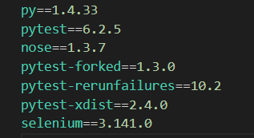
2. Ran **pip install -r Requirements.txt**
3. Created test scripts.
4. Execute it from the local and ensure the scripts are working fine.

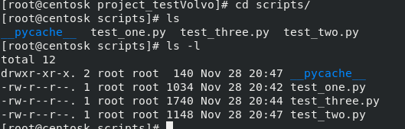

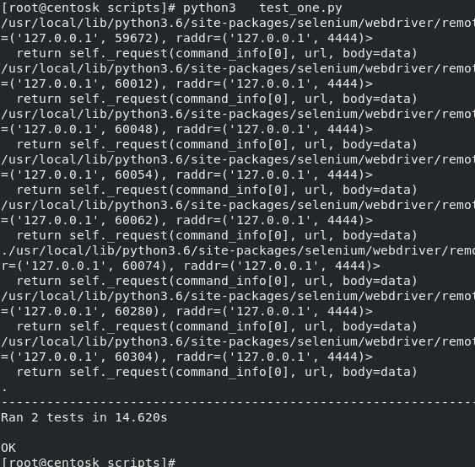

**Running the Scripts in docker**

1. Docker should be installed in the local machine.
2. Installed docker-compose as well for efficient deployment of containers.
3. Created docker-compose.yml file to build containerized selenium grid environment.

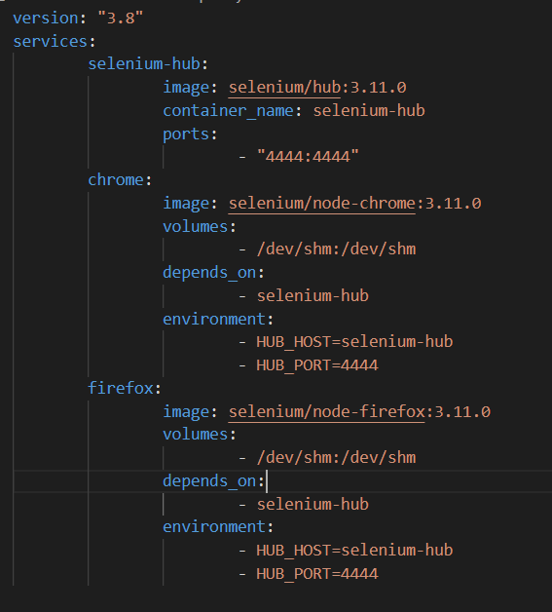

1. Ran **docker-compose up -d**
2. Made sure selenium grid is functional on browser
3. Containers are running with selenium hub along with node-chrome and node-firefox.
4. Command **docker container ls or docker ps**
5. Execute it in a docker containers and ensure the scripts are working fine.

Set up the Selenium Grid configuration using Docker.

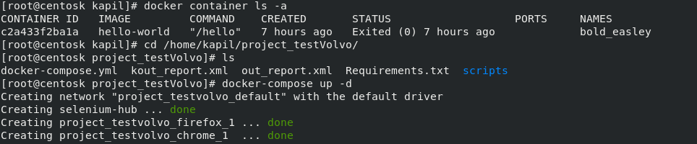

10. containers will be running on the local.



11. Ran parallel testing using command with report generation:

**pytest -n 7 --junitxml=./out_report.xml**

